BAGTASTIC

*User Guide*

|  |  |  |
| --- | --- | --- |
| **Supervisor.** | **Sir Shahryar** | |
| **Batch.** | **2207G2** | |
| **Group.** | A | |
| **Serial No.** | **Enrollment Number** | **Student Name** |
| 1. | Student1388784 | ZARYAB AHMED KHAN NIAZI, |
| 2. | Student1397261 | SYED QAISER ALAM, |
| 3. | Student1397281 | WAJEEH ABDUL REHMAN, |
| 4. | Student1395050 | NASAR KHAN |



1. **Navbar** (*index.html*)



***Figure 1: Navbar***

Arrow Slight curveWe have given five essentials. By clicking any of the essential’s and redirect to the linked page.

1. **Carousal (index.html)**

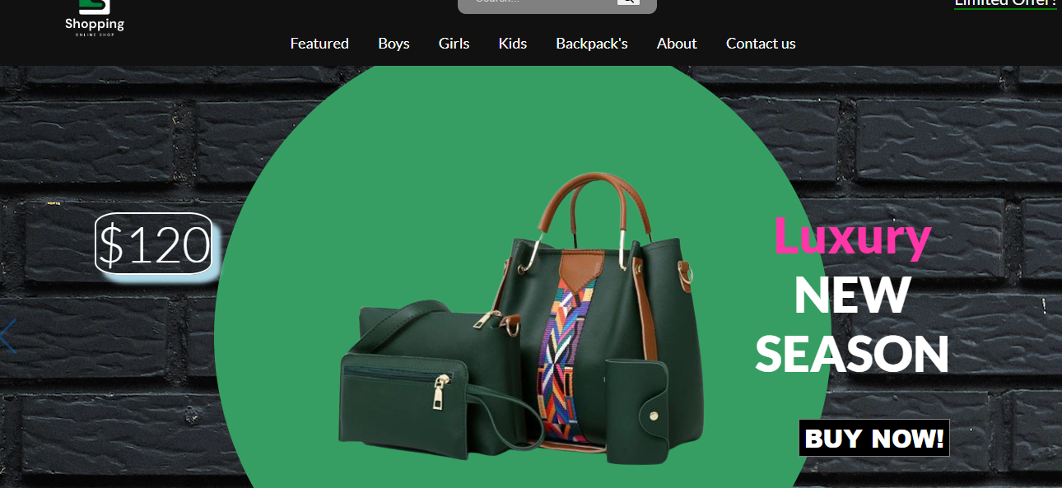***Figure 2: Carousal***

Arrow Slight curveWe have mentioned slogans on carousal.

Arrow Slight curveBy Clicking left and right arrow icon the image will be    changed.

1. **Introduction (index.html)**

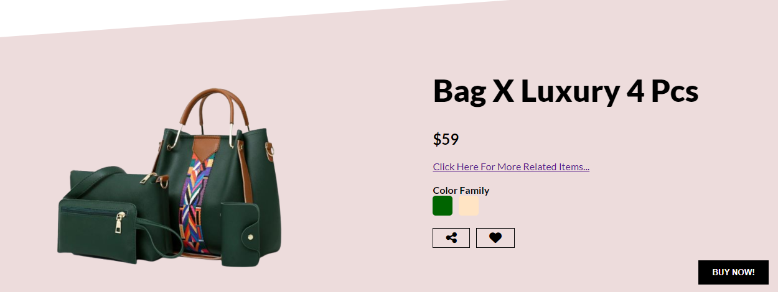

***Figure 3: Introduction***

**



*Arrow Slight curve*We have mentioned introduction and purpose of the website.

*Arrow Slight curve***BagTasTic OnLinE ShoPping,** is our slogan.

**4.About (about.html)**

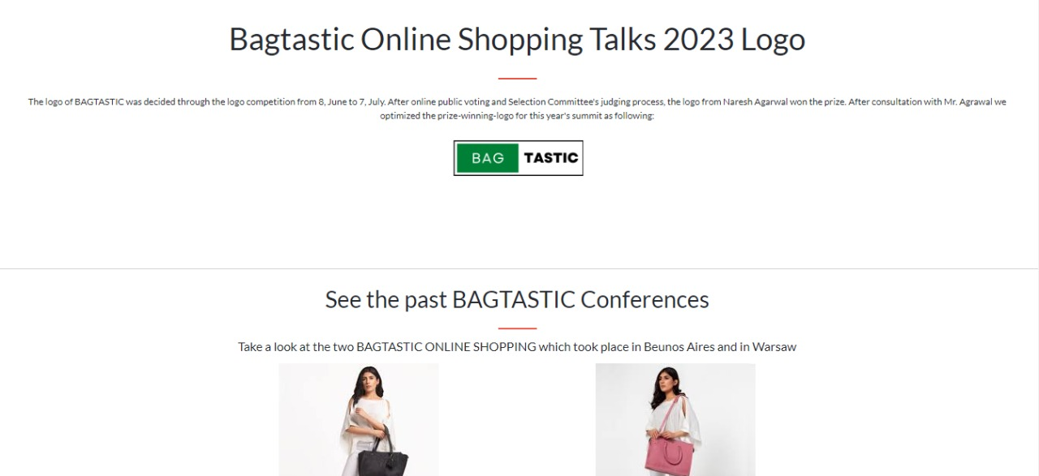

***Figure 4: about***

*We have mentioned our basic services to make people known about the service we provide.*

* ***Direct Purchase:*** *We are giving idea about direct purchasing from manufacturer.*
* ***Fastest Shipping:*** *We have mentioned that we are providing fastest shipping services to the customer.*

***5.Contact (contactus.html)***

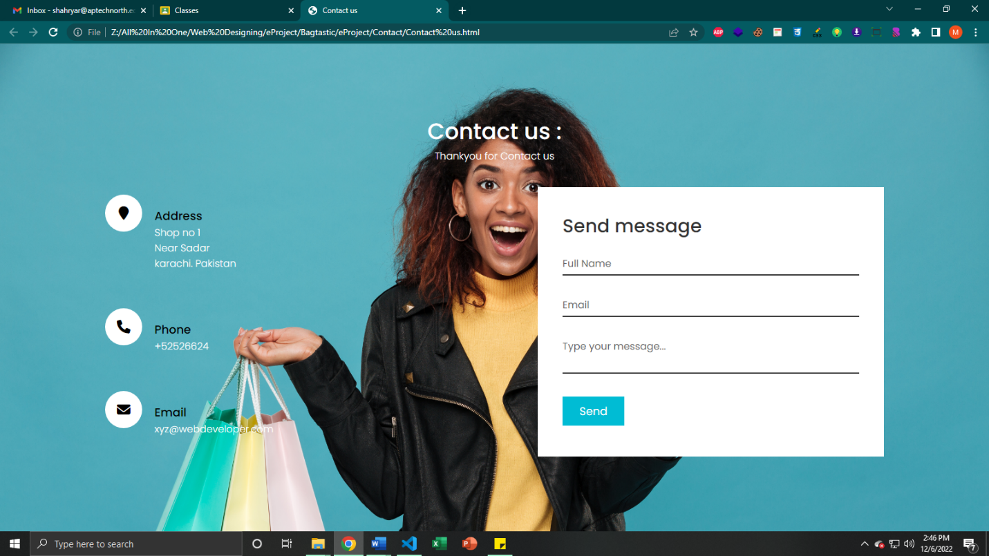



***Figure 5: Locations***

***Description:*** *We provide location of our branches in contact page.*

* ***Branch 1:*** ***Sindh, Karachi City, P.E.C.H.S Block 2.***
* ***Branch 2:*** ***F 28 Service Ln, Block 9 Clifton, Karachi, Karachi City, Sindh.***

***6.Menu bar:***



***Figure 6: Description of our Menu bar***

***Use to load the remaining pages. The following is a list of those Pages:***

* ***featured Page (1. index.html)***
* ***boys Page (2.boy.html)***
* ***girl Page (3.girl.html)***
* ***kids Page(4.kids.html)***
* ***backpack’s Page(4.backpack’s.html)***
* ***about page(4.about.html)***
* ***contact page(4.contact.html)***
* ***Categories Pages:***

*fancy carriages (5.fancy carriages.html)*

*bag it up(6bag it up .html)*

*pastel(7.pastel.html)*

*gucci(8gucci.html)*

*caviar beauty(9.cavaiar beauty.html)*

*fantasty bag(9.fantast.html)*

*surebages(9.surebages.html)*

*bagsinbulk(9.bagsinbulk.html)*

*owais bag(9.bakiowais.html)*

*mountain monk(9.mountain work)*

*life gear(9life gear.html)*

*beyond(9.beyoun.html)*

***7.Comparision (Bagtastic online shopping):***

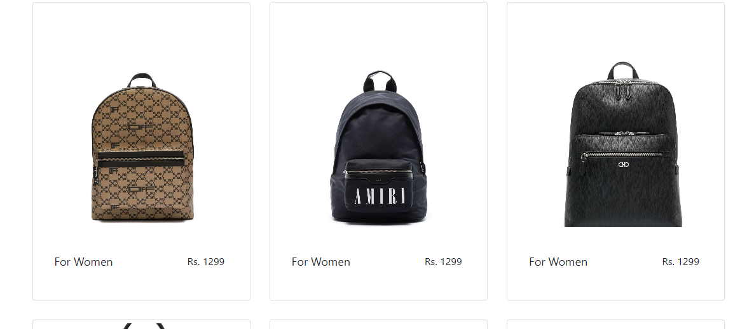

***Figure 7:Comparision Page***

***A comparison site doesn’t typically do anything that you can’t do yourself – but it takes a fraction of the time. Even if you could think of all the different providers to try, filling in each individual quote request would take you many hours. Using a comparison site allows you to compare a huge number of product instantly, a far more efficient way to get the job done.***

***8.Categories Pages***

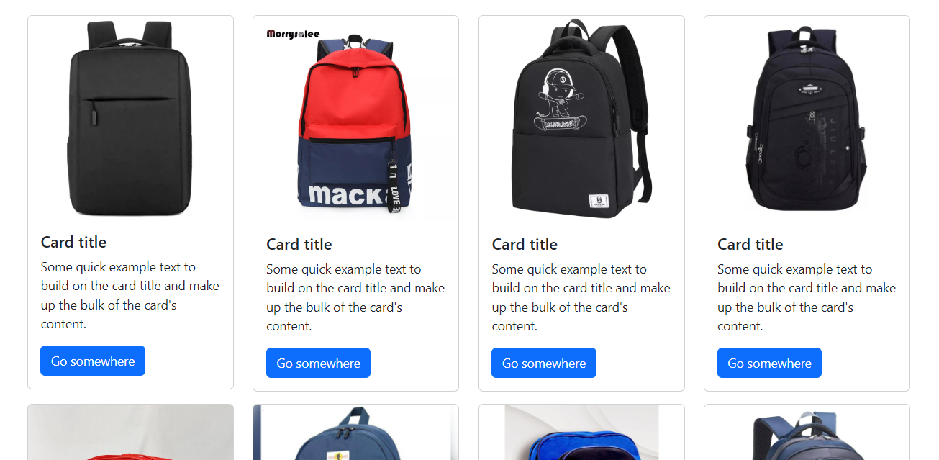

***We provide different categories pages.***

***9.Footer***

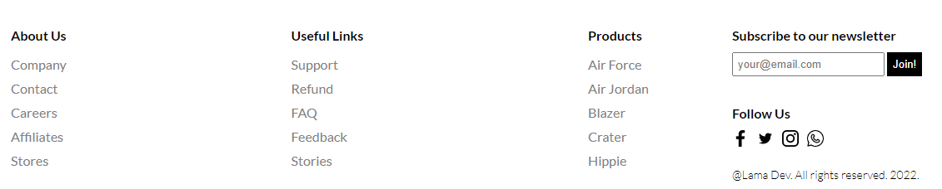

***We provide some links and our logo and slogan and search in footer.***

